High-precision optofluidic inclinometer based on curved nano-patterned superhydrophobic surface

Sebastian Wahlª, William César^{a,b}, Frederic Martyª, Tarik Bourouina^{a†} and Dan E. Angelescu^{a,c}

Received Xth XXXXXXXXXX 20XX, Accepted Xth XXXXXXXXX 20XX

First published on the web Xth XXXXXXXXXX 200X

DOI: 10.1039/b000000x

We present a novel dual-axis inclinometer based on a curved surface of controlled geometry, obtained using the large-scale deflection of a thin silicon membrane under the effect of a known differential pressure. Measurements are performed by recording the relative displacement of a liquid droplet (the mobile mass) from the membrane center, using a four-quadrant photodetector. A pattern of dense nano-scale needles is realized at the surface of the silicon membrane using a cryogenic plasma etching process that results in the formation of black silicon. A thin layer of fluorocarbon, subsequently deposited, leads to significant reduction of the contact angle hysteresis, resulting in a highly-accurate optofluidic inclinometer of metrological characteristics that are comparable to state-of-the-art macroscopic systems. Measurements performed with the same system but using liquid droplets and solid precision balls on polished membranes without nano-scale topography are also presented for comparison.

- Introduction

Inclinometers are finding wide applications in areas ranging from structure monitoring in civil engineering¹, to measurements of borehole inclinations in oilfield operations and glaciology², to posture recording in medical studies³, to name a few. In certain long-term applications, such as the continuous monitoring of major civil engineering works like large buildings, bridge pillars, and dams, sensors need to respond to a very demanding set of requirements: extended autonomy (as they may be embedded within structures), small measurement range (typically ±1°), high accuracy (0.01°), low cost, reduced power consumption (in the mW range), small size, and reduced maintenance. Bi-axial measurements may be necessary, requiring the use of two single-axis inclinometers, with consequent increases in power consumption, cost and logistics.
Many attempts at developing accurate miniaturized inclinometers have been reported, most often implementing some type of pendulum coupled to detection methods based on various physical principles (e.g. resistive⁴, capacitive⁵⁻⁷, electrolytic⁸⁻⁹, magnetic¹⁰, optical¹¹⁻¹², thermal¹³⁻¹⁴ and photoelectric^{15–18}). Commercial systems based on dual-axis MEMS accelerometers can deliver accuracies of order 0.1° over a full 180° range, albeit with relatively high power consumption¹⁹ (> 30mW). Currently, the only systems that can achieve the satisfactory combination of the range and accuracy requirements for civil engineering monitoring are large-scale pendulum inclinometers (force-balance tilt sensors) coupled with optical detection, yet they do not satisfy the cost, size, and power consumption criteria for long-term monitoring applications.
Black Silicon has recently been the focus of considerable scientific interest³⁴⁻⁴² because of its interesting physical optical and wetting properties. Especially its superhydrophobic behaviour has been extensively investigated and makes it an interesting surface for a number of practical applications, for example, “selfcleaning” windows or solar panels⁴², “lotus-effect” paints³⁹, waterproof clothing³⁷, anti-icing surfaces³⁸ and also laminar flow enhanced microfludic systems^{40,41}.

ª Université Paris-Est, ESYCOM Lab, ESIEE Paris 2 Bd Blaise Pascal, 93162 Noisy-le-Grand, France.
^{b} Now with FLUIGENT, 1, Mail du Professeur Georges Mathé, 94800 Villejuif, France.
^{c} Now with FLUIDION, 94 Avenue du Général de Gaulle, 94000 Créteil, France.
† corresponding author E -mail: tarik.bourouina@esiee.fr

Drops that come into contact with a superhydrophobic material retain a nearly spherical shape, remain extremely mobile and roll off even if only very small tilts are applied to the substrate. As has been shown, this effect results from a wetting situation (referred to as Cassie or composite wetting) where liquids no longer penetrate, but rest on top of the roughness features^{34,43} leading to very high contact angles (both advancing and receding) and the CA hysteresis, Δθ, is close to zero^{34,35}. Recent research has suggested that this “truly” superhydrophobic behaviour is correlated to several factors such as surface size scale⁴⁴, shape and topography of the roughness feature⁴⁵, solid fraction⁴⁶ of the substrate in contact with the drop footprint and substrate surface chemistry⁴⁷. This superhydrophobic behaviour of black silicon and high sensitivity to even small tilt angles combined to its ease of manufacturing, thus makes it a very promising (yet unreported) candidate for lowcost and accurate tiltmeasuring systems. as described in what follows.

- Sensor principle

In this paper we are presenting a novel inclinometer principle, using a mobile mass rolling (or even sliding) over a curved surface (Fig. 1) whose shape and wetting properties are precisely controlled so as to enable reaching the required metrological grade. The surface curvature is produced by bending a thin silicon membrane brought into the large deflection regime, under the effect of a vacuum-enabled permanent differential pressure. This provides a significant curvature as well as a perfectly-controlled shape of the membrane surface acting as the substrate for the mobile mass. We show hereafter that maximal membrane surface slopes of several degrees, which correspond to the range of interest for the majority of inclinometer applications, can be obtained under a differential pressure of 1 Bar; hence, such differential pressure level can be easily obtained by applying vacuum within a cavity on the back-side of the membrane, while the front-side is kept at atmospheric pressure. The geometry of the surface can be designed and computed with any degree of precision (by using highly-accurate numerical models or even analytical approximations).It is worth-mentioning that the membrane-based curved structure keeps the intrinsically excellent surface quality of the –initially flat– bare polished silicon wafer; such surface quality over the whole curved surface is indeed impossible to obtain by alternative microfabrication etching techniques capable of creating curved surfaces^{20,21}.

By using either solid balls or liquid metal droplets acting as the mobile mass placed on the curved membrane, we show that a highly-sensitive bi-axial inclinometer can be manufactured. We implement a detection system using an infrared LED and a quadrant photodetector, placed on opposite sides of the membrane. The accuracy of the solid ball system can be disturbed by ball sphericity and surface roughness imperfections or by the presence of particles on the membrane, these effects can be reduced by assembling the system in a clean room setting and using high-precision mechanical balls. Precision superior to 0.050° could be obtained using this approach. On the other hand, the errors obtained when using a liquid (mercury) droplet as the moving mass, stem from physical causes such as contact angle hysteresis, and their elimination requires additional surface processing steps.
(a)

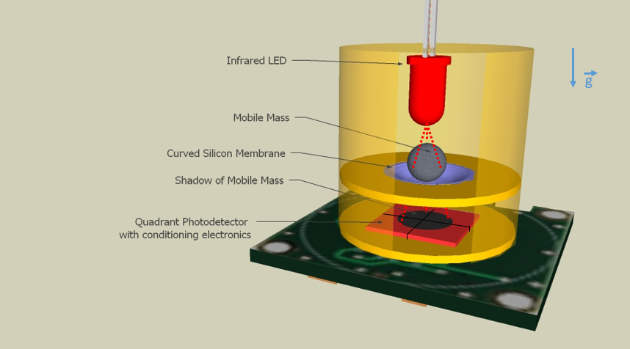
(a)
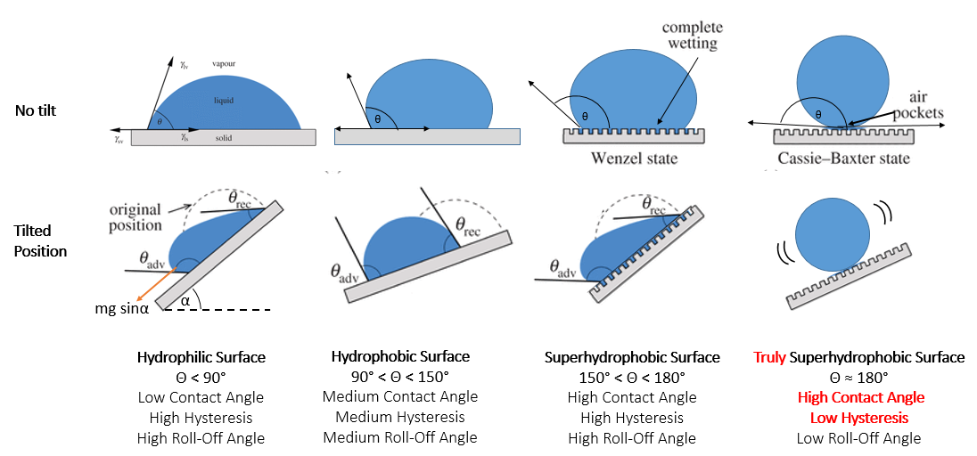(b)

Fig. 1 (a) Operation principle schematic diagram identifying the different building bricks of the inclinometer. Gravity direction is vertical, as indicated by the vector ~g. The red lines originating from the LED represent light rays intended as guides to the eye. (b) Liquid droplet displaying different wetting behaviors in a no-tilt and tilted position respectively on a hydrophilic, hydrophobic, superhydrophobic and truly superhydrophobic surface.

When using liquid droplets instead of solid balls as the mobile mass, the contact angle hysteresis becomes a critical point as it will affect measurement accuracy. Indeed, in case of large hysteresis of the contact angle, the droplet does not move immediately upon tilting as it will remain stuck to the surface for some time before starting its motion. In order to reduce the contact angle, we subjected the silicon membranes to a cryogenic deep reactive ion etching (cryo-DRIE) step to create well-controlled dense nano-scale topography typical of black silicon²² (BSi) over the curved membranes. By further coating the resulting nano-structured membranes with a plasma-deposited fluoropolymer thin film, we create a strongly non-wetting, superhydrophobic surface with extremely low hysteresis of the contact angle, a phenomenon we, and others, recently reported in literature^{23,24}. Figure 1b summarizes the wetting behavior of a droplet on different surfaces with respect to contact angle, hystereris and roll-off angle. We show herein that this combined nano-topographic and chemical treatment of a curved surface leads to a truly superhydrophobic surface that combines high contact angle with low hysteresis and low roll-off angle which in turn results in highly improved inclinometer performance compared to the case of a smooth, polished membrane, with precisions that can reach down to 0.007°.

- Materials and methods

3.1 Fabrication of the inclinometer chip core

Figure 2a illustrates the fabrication sequence. The curved membrane was fabricated from a 400µm-thick double-side polished Si wafer, by etching a circular cavity using Deep Reactive Ion Etching (DRIE). The thickness of the membrane was controlled either by etching time, calibrated using topographic measurements by optical interferometry, or by using a silicon-on-insulator (SOI) wafer in which case the buried oxide layer acts as an etch stop, resulting in a perfectly controlled thickness. The experiments reported here used a membrane with a thickness 20.0 µm ±0.5 µm and a radius of 2.83 mm. After etching, the cavity behind the membrane was sealed with a 500 µm-thick borosilicate glass wafer, using a vacuum anodic bonding process. When vacuum was released, the membrane deflected towards the vacuumed cavity due to atmospheric pressure force. Using an optical profiler (WYKO NT1100) we measured a deflection of 89.8µm at the membrane center, for an atmospheric pressure of 1010 mBar. This was consistent with nonlinear large-scale deflection simulations performed using the Ansys finite element analysis package, which yielded a value of 90.4µm. An image of the deflected membrane (in this case without nanostructuration) is provided in Figure 2b, top left.

To create BSi nanostructuration on the silicon membrane, a second lithographic step was used to provide an etch mask on the side of the silicon wafer containing the membranes, and the bonded Si-glass wafer sandwich was then subjected to a cryogenic plasma processing following a procedure that was described elsewhere²² (Figure 2b, bottom left). Following the cryogenic etch, the surface acquired a complex topography consisting of high aspect ratio pillars spaced approximately 100 nm apart. A 100 nm-thick film of fluoropolymer was subsequently deposited in the same plasma reactor, using the passivation mode of the room-temperature Bosch etching process (note that the fluoropolymer film was conformal, so the actual average thickness on the BSi surface was closer to 1000 nm, given the 10:1 surface enhancement factor typical of BSi topography²⁵ – Figure 2b, top right). The surface exhibited a low surface energy resulting in highly non-wetting behaviour with mercury, as shown in Figure 2b, bottom right (only a lower bound of > 165° could be established for the contact angle, due to obstruction by the edge of the deflected membrane).

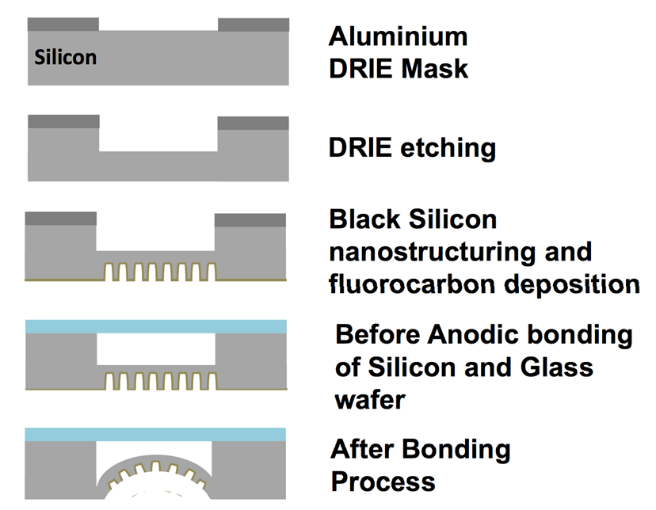  (a) | 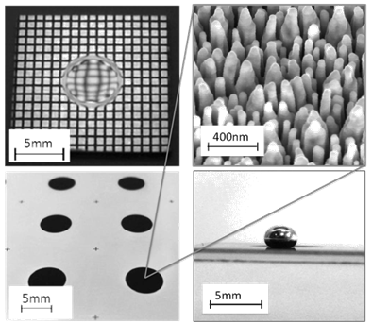  (b)
Fig. 2 (a) fabrication sequence of the curved silicon surface in this case including the nanostructuration and surface treatment for superhydrophobicity and low hysteresis contact angle; (b) Left top: Smooth polished silicon membrane (here without nanostructuration). Membrane deflection visualised by deformed reflection of a square grid. Left bottom: photograph of an array of membranes subsequent to the nanostructuration step (within the dark circles of Black Silicon). Right top: Electron microscope image of the surface of a nanostructured membrane, after Black Silicon formation and fluoropolymer conformal coating. Bottom right: Image of a liquid metal droplet (mercury) placed on top of the nanostructured, chemically treated, deflected membrane.

3.2 Experimental setup

The core of the system is the dual-axis sensor shown schematically in Fig.1. The detection of the mobile mass movement was performed optically, using a projected shadow technique: an infrared LED (λ = 1070 nm from Thorlabs LED1070E) was centered above the membrane and mobile mass, with light traversing the silicon membrane and being detected on a quadrant photodetector packaged with conditioning electronics (First Sensor QP45-Q-HVSD High-Voltage Quadrant Sum and Difference Amplilfier). The selected photodetector is sensitive across the near-infrared range, with maximum responsivity reached at λ =975 nm (0.60 A/W) and decreasing by 29% (0.42 A/W) at λ =1070 nm. The detector output consisted of three signals: the sum of the four quadrant outputs (SUM signal), the difference between the left and right half of the detector (LR signal) and the difference between the bottom half and the top half (BT signal).

The membrane, light source, mobile mass and detection electronics were assembled using a custom-machined aluminum part (Figure 3a). The electronics board was mounted on the back side, with the center of the four-quadrant detector directly underneath the center of the silicon membrane. An o-ring was placed in a groove machined between the silicon membrane and the aluminum component, to allow the use of a liquid medium around the mobile mass in further experiments. The mobile mass was added to the membrane, carefully placing it at the center using tweezers for the solid balls (precision steel balls grade 100 and 10 from Marteau & Le Marié), or a syringe connected to a 500 µm internal diameter PFA capillary tube (from Upchurch Scientific) in case a liquid metal droplet is used. The droplet size was controlled by the length of the mercury column in the tube and can be chosen in the range from 2 mm to 3.5 mm diameter. All manipulations involving exposed mercury were performed in a chemical fume hood. The LED was mounted on a small printed circuit board, and placed directly above the silicon membrane thus sealing off the device. Power was provided by laboratory voltage supplies, and all data was recorded using a data acquisition board (model 6259 from National Instruments) connected to a PC, and a custom user interface developed using the LabWindows CVI software package (National Instruments).

The complete system was mounted on a rigid aluminium plate (Figure 3b), along with two uni-axial reference inclinometers (Schaevitz LSOP/LSOC-3 from Sherborne Sensors Limited) that were used to record the x and y values of the inclination. These reference inclinometers are force balance sensors that are used as standard equipment in civil engineering monitoring applications, and have a measurement range of ±3° and a precision of 0.0006°. The inclination of the plate could be controlled in both x and y directions using two sets of fine-thread adjustment screws.

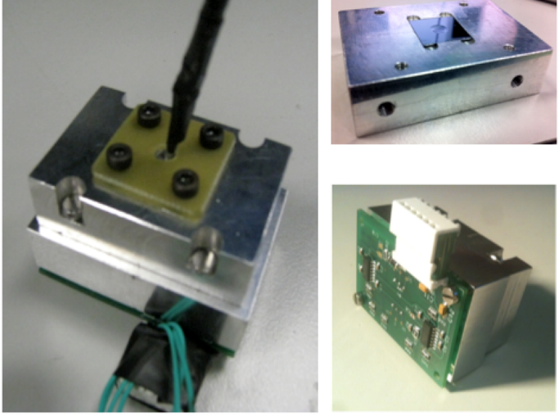  (a) | 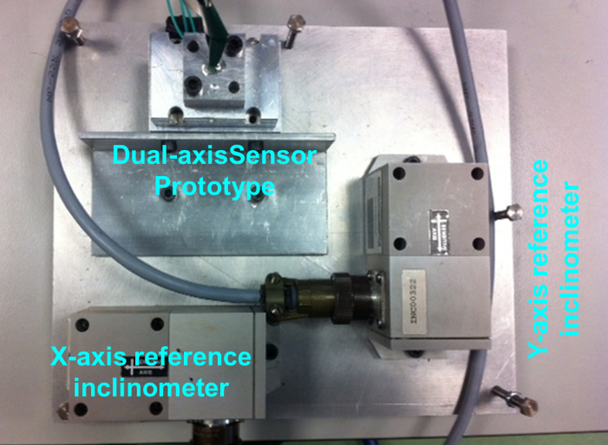  (b)
Fig. 3 (a) Left: Photo of the experimental setup, showing the fully-assembled prototype inclinometer. Top right: partially assembled prototype, with the curved membrane exposed. Bottom right: the detection electronics (b) Fully assembled dual-axis sensor prototype mounted on an inclinable table embedding two reference inclinometers along the X-axis and Y-axis.

  - Improved prototype

The experiments done with the previous prototype essentially showed two major limitations in its use: the membranes and the packaging. These limitations led to the fabrication of a new improved prototype which is detailed below.
The membranes were an issue because the deflected membranes were in direct contact with the rest of the silicon chip which eventually enabled the mobile mass to leave the center of the sensor. The sensor being completely sealed this didn’t cause any other perturbation except that it made a correct measurement impossible. To improve this, the new membranes figured an additional glasslayer with circular opening around the membrane in order to prevent the mobile mass to leave the membrane and get in contact with the rest of the chip, even in the case of strong tilts or vibrations. Figure 4a shows an example of this new type of membrane.
The previous packaging on its own showed very good results but proved usability issues as it didn’t allow 360° tilts which would cause handling issues in real-life operational situations. The new packaging ensures a complete isolation of the photodiode-membrane couple. At the end of the packaging assembly, the cavity containing these elements are isolated by o-rings and garments which prevents leaking of a fluidic mobile mass and enables the use of a second immiscible liquid (Fluoroinert F-70) surrounding the liquid mobile mass. Thus the packaging ensures a totally inert and easy to manipulate sensor. Figure 4b shows 2D and 3D-renderings of the new packaging as well as a photo of the actual prototype placed on the test platform.
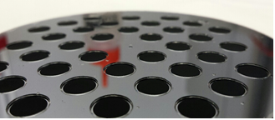 | 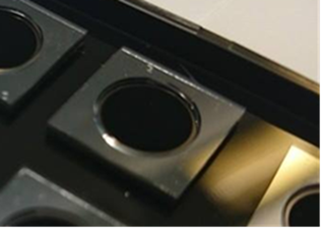
(a)
 | 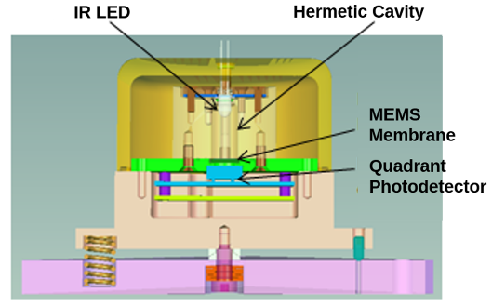 | 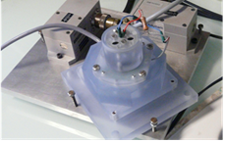
(b)
Fig. 4. (a) Left: photo of the new MEMS membranes figuring black silicon and an additional glass layer with circular openings to prevent the mobile mass from leaving the membrane center. Right: photo of a single membrane after wafer dicing. (b) Left: 3D model overview of the new sensor and its packaging. Right: Sliced view of the sensor showing the different elements and how they integrate into the packaging. Bottom right: Photograph of the actual sensor on the test platform.

4 Design considerations

The large scale deflection of elastic membranes has been investigated for close to a century²⁶, with recent studies improving the precision of the results^{27,29,30}. However, due to the highly non-linear nature of the elasticity equations in the large-deflection regime, a full analytical solution is not always possible. In the case of circular membranes, the center deflection and maximum stress can be calculated²⁸ as a function of the geometry and applied pressure differential. Some applications of membranes under large scale deflection have been investigated, such as inflatable reflectors for space usage²⁹, yet in the area of microelectromechanical systems (MEMS) the usage of membranes for pressure sensors and thermal flow sensors has been largely restricted to the linear low-deflection regime (few exceptions exist, such as in the case of certain membrane-based micropumps³¹).

The deflection of an elastic circular membrane under uniform applied differential pressure has been extensively studied and its profile can be evaluated in a first approach based on exact calculations provided by linear elastic theory^{28,32}:

(1)

with r₀ being the membrane radius, and y_{c} the maximum center deflection.

(2)

where Δp is the applied differential pressure, D = Et³/12(1 – υ²) is the plate constant, υ the Poisson ratio of the membrane material, E the Young modulus and t the membrane thickness,
The profile in Equation 1 has an inflection radius (corresponding to the maximal possible radial displacement of the inclinometer’s mobile mass prior to its equilibrium becoming unstable) located at
(3)
and a corresponding inclination angle (representing the largest angle that is measurable with this type of inclinometer):

(4)

However, in the case of large-scale deflection of a circular membrane under uniform pressure load, the equations become non-linear, and in this case, the deflection profile lacks a simple analytical expression³² but it can be obtained with good accuracy using a variety of numerical techniques. The profile for specific membrane geometries can be obtained by non-linear finite element analysis techniques. Nevertheless, to a reasonable degree of accuracy, it can be approximated by the linear-elasticity profile represented in Equation 1 by replacing y_{c} with the actual center deflection³³.

The different elements of the inclinometer need to be scaled in order to allow the correct range of measurement to be reached. In particular, the geometric parameters of the membrane need to be adjusted so that θ_{max} corresponds to the range of interest (in our case, ±1°). An infinity of solutions, corresponding to different choices of r₀ and t, are possible. The proper choice is necessarily a compromise involving on a number of factors, such as the size of the detector, the desired final package size, the emission angle of the light source, the size of the mobile mass and, last but not least, the manufacturability constraints. In our case, we chose a silicon membrane radius of r₀ =2.83 mm with a thickness t of 20.0 ± 0.5 µm. The resulting center deflection was measured at 89.8 µm, leading to a theoretically expected maximal measurement range of ±2.8° and an inflection point radius of r_{inf} = 1.63 mm. The mobile masses used (for both solid balls and liquid droplets) ranged in diameter between 2 mm (in which case the measurement range was limited by the mobile mass shadow leaving the center of the detector prior to reaching the inflection point radius) and 3.27 mm (the smallest dimension enabling the full theoretical range of the inclinometer to be attained).
Different sets of experiments have been conducted with the two types of membranes previously described in section 2.1. The different inclinometer configurations and associated precision results from repeatability tests are summarized in Table 1. These configurations differ from each other mainly on two parameters: (i) nature of the curved surface depending on the use of either polished membranes or nano-structured superhydrophobic membranes, (ii) nature of the mobile mass, depending whether solid balls or liquid droplets are used, as well as the corresponding quality grades of the solid balls and nature of the liquid droplet and its surrounding environment. The corresponding experimental results are described in the following sections 3.1 and 3.2, respectively.

Sensor version | S-B-100 | S-B-10-1 | S-B-10-2 | NS-L-1 | NS-L-2 | NS-L-3-F | Reference Sensor
Surface quality | Polished Silicon |  |  | Nanostructured  (Black Silicon & fluorocarbon coating) |  |  | -
Material of the mobile mass | Solid (steel) balls |  |  | Liquid (mercury) |  | Liquid (mercury) | -
Quality grade of the mobile mass (sphericity error) | Grade 100  (<0.25 µm) | Grade 10  (<0.025 µm) |  | - | - | - | -
Diameter of the mobile mass | 3.17 mm | 3.17 mm | 2.38 mm | 2 mm | 3 mm | 2,5 mm | -
Environment of the mobile mass | Air | Air | Air | Air | Air | Fluorinert  FC-70 | -
Noise standard deviation  results | σ_{x} = 0,0011°  σ_{y} = 0,0009° |  |  |  |  |  | σ_{x} = 0,0211°  σ_{y} = 0,0215°
Standard deviation results from Repeatability Tests | σ_{x} = 0,133°  σ_{y} = 0,081° | σ_{x} = 0,059°  σ_{y} = 0,067° | σ_{x} = 0,063°  σ_{y} = 0,033° | σ_{x} = 0,051°  σ_{y} = 0,024° | σ_{x} = 0,0126°  σ_{y} = 0,0073° | σ_{x} = 0,01°  σ_{y} = 0,0079° | σ_{x} = 0,016°  σ_{y} = 0,02°
Table 1. The different inclinometer configurations considered in this study.

5
Results and Discussion

  - Experiments on polished membranes

A first measurement campaign (involving the sensor versions S-B-100, S-B-10-1 and S-B-10-2 as detailed in Table 1) has been performed with an untreated surface of the silicon membrane and different sets of high precision balls. Grades and dimensions have been varied to study the influence on the behavior, the resulting linear range and precision of the inclinometer. In particular, two dimensions have been studied (2.38 mm and 3.17 mm diameter high precision steel balls) and 2 grades (grade 100 and grade 10). Concerning the grading, its influence can be described as follows: the lower the grading of the precision ball the smaller the surface roughness variations and sphericity errors and the higher the assumed predicted precision of the inclinometer. To be extensive the grade 100 corresponds to surface roughness variations of 0,25 µm and sphericity error of 2,5 µm and grade 10 corresponds to surface roughness variations of 0,025 µm and sphericity error of 0,25 µm. The prototype output data has been normalized by dividing the axis-sensitive voltage outputs of the photodiode (left minus right, top minus bottom) by its voltage sum. A linear fit has been performed on experimental data to obtain a slope calibration coefficient. The offset has been measured at 0° inclination and removed prior to plotting the data. The prototype output shows a ±1° linear range with good correlation to the reference inclinometer measurements. Imprecision is introduced through random surface roughness distribution and sphericity errors of the mobile mass. To estimate the precision of the sensor, repeatability tests have been performed. Repeatability tests have been done by placing the prototype in a no-tilt position and realizing repeated large angle tilts (>10°) and coming back to zero.

The results of these first experiments are shown in Figure 5. We can clearly identify different conclusions: Firstly, the precision of the measurements directly depends on the grading of the precision ball. Secondly the size of the precision ball also affects the size of the linear range of our measurements. Best results for this first batch, of polished membranes with untreated,surfaces show standard deviations of respectively 0.033° and 0.063° in y and x direction for a grade 10 precision ball. Even better results could have been obtained by selecting even lower-graded balls but physical constraints (and taking account of costs) involved in machining these precision balls would not lead to much better results we believe.

(a) 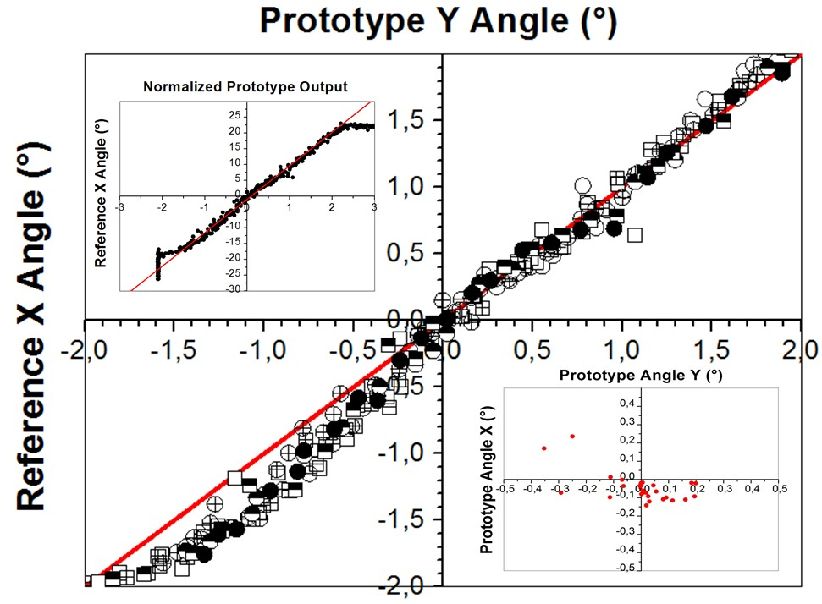

(b) 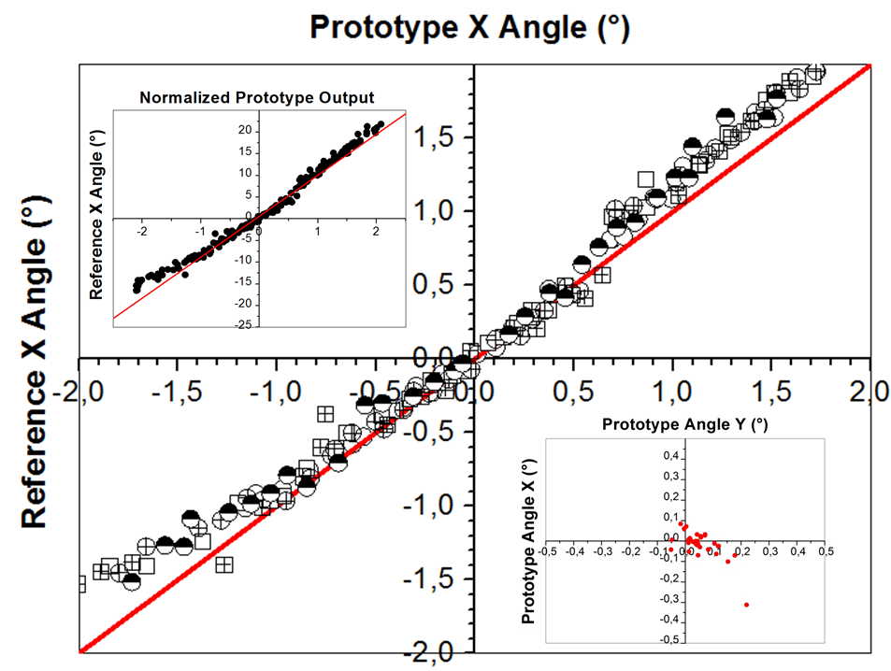
(c) 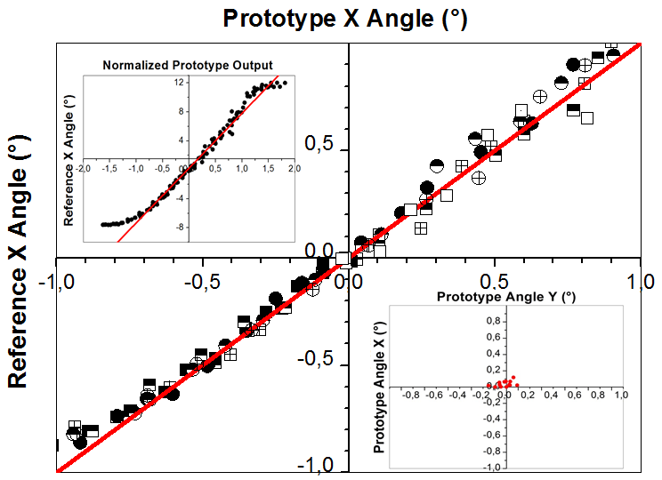
Fig. 5: Experimental results obtained on the unstructured membrane in 3 different configurations of the mobile mass: (a) Sensor version S-B-100 with a grade 100 high precision steel ball of 3.17 mm, (b) Sensor version S-B-10-1 with a grade 10 high precision steel ball of 3.17 mm and (c) Sensor version S-B-10-2 with a grade 10 high precision steel ball of 2.38 mm. The plots in the main graphs show a relatively good correlation between prototype and reference inclinometer measurements over the ±2° linear range in (a) (b) and ±1° in (c). No sign of hysteresis (ascending sweeps with circles, descending with rectangles). Top left Inset: Normalized output of the prototype. Flattening outside the linear range is due to mobile mass touching the inner edge of the mechanical device in cases (a) and (b) while in case (c), it is due to mobile mass shadow leaving center of quadrant detector Linear fit to obtain calibration coefficient of 10,61/° in case (a); 9,44/° in case (b) and 7,6/° in case (c), respectively. Bottom right Insets: Repeatability test following large angle tilt (>10°) showing standard deviation: y = 0,081°, x = 0,133° in case (a); y = 0,067°, x = 0,059° in case (b) and y=0,033°, x=0,063° in case (c), respectively.

  - Experiments on nano-structured membranes

A second measurement campaign (involving the sensor versions NS-L-1, NS-L-2 and NS-L-3-F as detailed again in Table 1) has been performed with a nanostructured and chemically treated silicon membrane and respectively a first mercury droplet of approximatively 2 mm diameter and a second one of approximatively 3 mm diameter. The results of the 2 mm diameter mercury droplet are illustrated in Figure 6a and clearly show significant hysteresis effects between ascending and descending measurements (data points show a linear progression but are shifted by an offset dependent on the direction of angle change). Repeatability tests show improved standard deviation results of respectively 0.024° and 0.051° in y and x direction which already shows that choosing a second set of nano-structured and chemically treated membranes combined with a mercury droplet is a promising approach.
Increasing the droplet size to 3 mm diameter show improved sensor precision results by reducing the hysteresis effect with standard deviation results of respectively 0.0073° and 0.0126° in y and x direction as illustrated in Figure 6b.

(a) 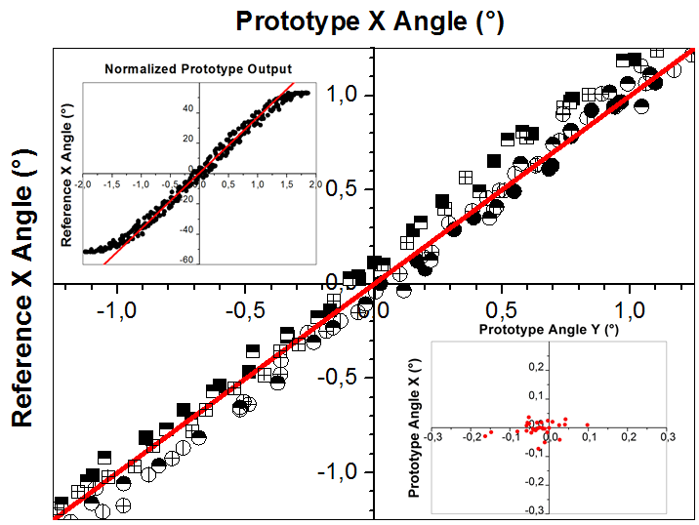

(b) 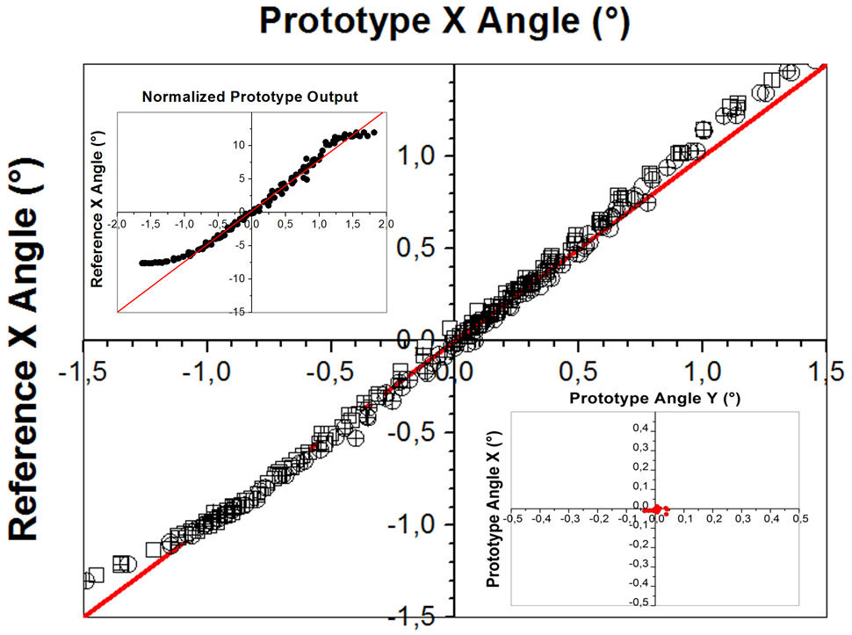
Fig. 6: Experimental results of the structured membrane with two values of the droplet diameter: 2 mm in case (a) and 3 mm in case (b) respectively corresponding to sensor versions NS-L-1 and NS-L-2. The main graph plots show significant hysteresis effects in case (a) and low hysteresis effects in case (b), for prototype inclinometer measurements over the ±1° linear range (ascending sweeps with circles, descending with rectangles). Top left Inset plots show the full range normalized prototype output in x-direction. Linear fit to obtain calibration coefficient of 36,8/° in case (a) and 7,6/°in case (b), respectively. Bottom right Inset: Repeatability test following large angle tilt (>10°) showing standard deviation: y=0,024°, x =0,051° in case (a) and y=0,0073°, x=0,0126° in case (b)

5.3 Experiments on the fully-assembled prototype

New measurement campaigns were originated with the improved prototype and led to additional results that are detailed in Figures 7 to 10. A 2.5 mm mercury droplet was placed inside the device on the center of the newly fabricated membrane, and a thermally and chemically stable fluid (Fluorinert FC-70 from 3M Company) was used to surround the droplet in order to minimize its aging and also to stabilize the sensor making it less sensitive to vibrations from the environment. The measurement stage was initiated in order to have the reference sensor perfectly centered at 0° in x and y-axis. The prototype was then initiated in order to have its signal superposed and centered on the reference signal.

5.3.1 Initial experiments

A first experiment was undertaken to perform a noise measurement of both inclinometers by just taking a large set of data points at zero inclination. Without averaging or additional data manipulations, the prototype signal shows clearly less noise than the reference inclinometers (by a factor 20) as shown in Figure 7 (left). Reference and prototype inclinometers show respectively a standard deviation of approximatively 0.02° and 0.001°. A second experiment was undertaken to perform repeatability measurements on both inclinometers by tilting the measurement stage in different random directions and at different angles and measuring the angle to which the inclinometers stabilize after a time interval of 10 seconds (as shown in Figure 7 – right). Standard deviation results are performed in both x and y-axis. The standard deviation result of the reference inclinometer is of the same order as its noise whereas the prototype clearly shows higher standard deviation results as its noise – which implies that the droplet does not exactly stabilize at the same position after each measurement.

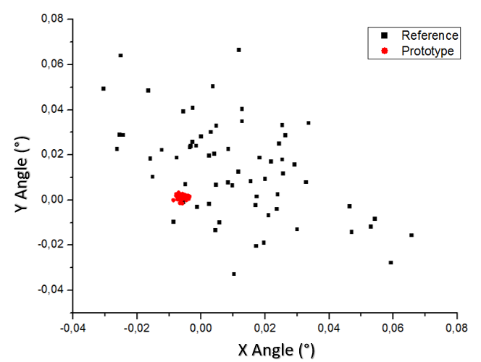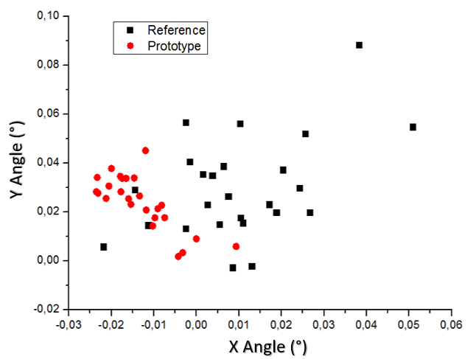

Fig. 7. On the left: Noise measurements performed on reference and prototype inclinometers at zero tilt. Standard deviation results show respectively errors of approximatively respectively 0.02° and 0.001° in both x and y direction. On the right: Repeatability measurements performed on reference and prototype inclinometers at random tilt and direction. Standard deviation results show errors of approximatively respectively 0.016° and 0.0079° in x-direction and 0.02° and 0.01° in y-direction.

Response times of both sensors have been investigated by initiating a large angle tilt (either only in x-direction or in xy-direction), getting back to zero tilt position and by taking data points at fixed 0,5 second time intervals. These experiments enable to visualize response times and also mobile mass displacement of the prototype sensor. The observations (as shown in Figure 8) for a tilt in x-direction only show that both reference and prototype sensors get back to the initial position in less than 2 seconds – meaning that the mercury droplet does not “stick” to the edge of the membrane and quickly gets back to the membrane center and stabilizes there. Identical observations have been made for a tilt in xy-direction showing the bi-axial character of the prototype sensor.

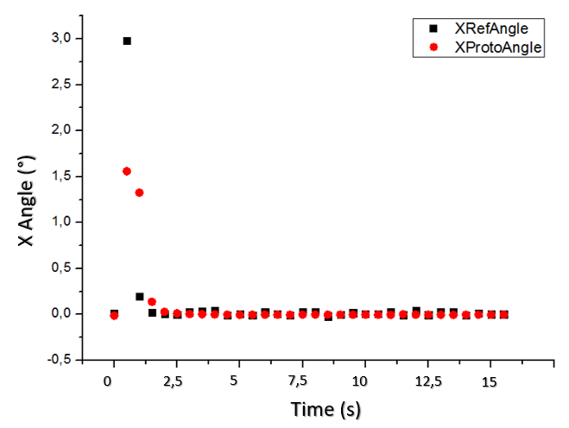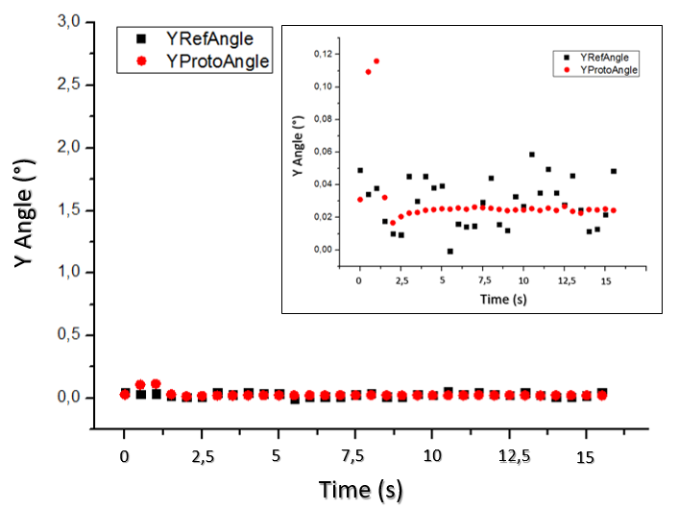

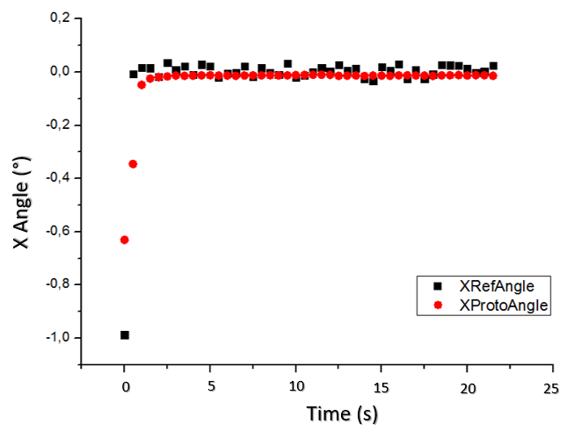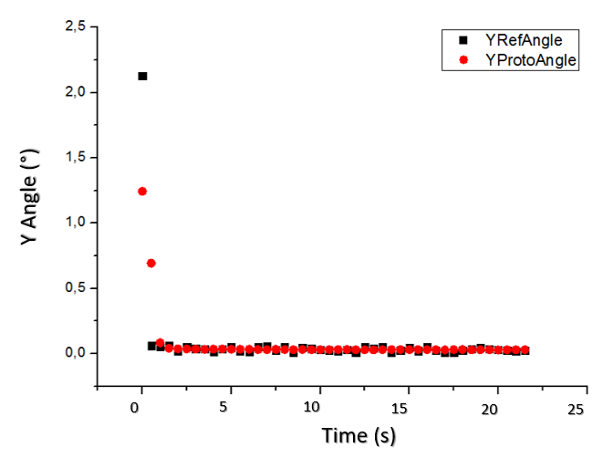

Fig. 8. Top row: Response time and temporal behavior of reference and prototype sensors following a large angle tilt in x-direction, results shown for the x-angle (left) and y-angle (right). The y-angle result graph displays an inset whose graduation has been chosen in order to show the noise of the two sensors. Bottom row: Response time and temporal behavior of reference and prototype sensors following a large angle tilt in xy-direction, results shown for the x-angle (left) and y-angle (right). Time interval of 2 acquisitions per second. Both prototype and reference sensors show a stabilization around the initial (0°, 0°) position in less than 2 seconds.

Cyclical measurements have been performed in order to test hysteresis of the prototype sensor. Ascending and descending sweeps in x-direction have been performed beginning from the initial (0°,0°) position. The measured x-angle value of the prototype has been plotted against the measured x-angle value of the reference sensor. During the first three full cycle sweeps the correlation between both values has been very good, but further sweeps introduced significant hysteresis effects after the third cycle as shown in Figure 9. The measured linear range of the prototype sensor was ± 1.25°.

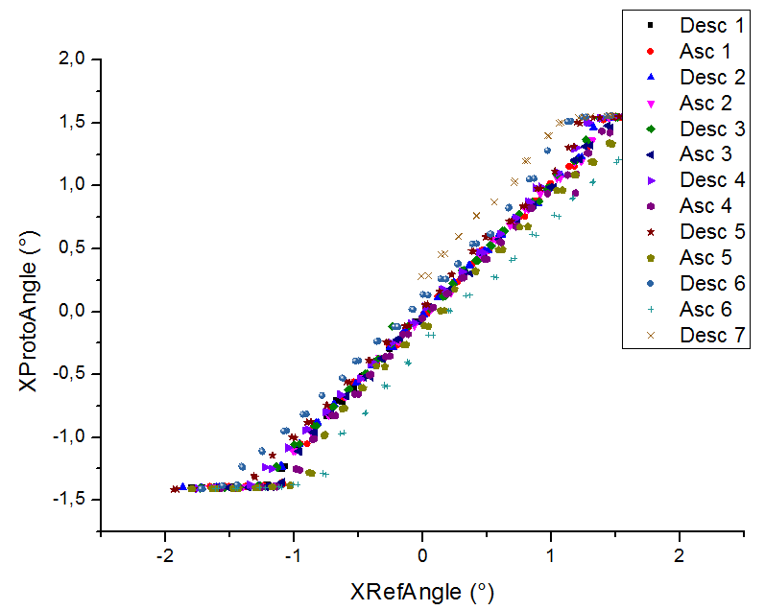

Fig. 9. Prototype sensor cyclical measurements: Several ascending and descending sweeps have been performed in x-direction and the measured x-angle of the prototype has been plotted against the reference. While the first 3 sweeps showed a good correlation, the following sweeps showed hysteresis through significant angle deviations.

5.3.2 Effect of time on sensor precision and measurement consistency

In order to analyze the effect of time on sensor precision and measurement consistency, exactly the same experiments have been performed a couple of hours later in the same conditions than before with the exact same device and mobile mass as described in section 4.3.1. Prototype sensor noise measurements have not been reproduced because they are not affected by time and the noise is due to conditioning electronics.

Response time experiments have been performed in x-direction and in xy-direction as shown in Figure 10. Whereas before the prototype sensor stabilization occurred in less than 2 seconds, this time the stabilization time seems to be much higher (with a first stabilization plateau occurring at 15 seconds), and the mobile mass does not stabilize at the initial (0°, 0°) position and seems to slowly continue shifting back to the initial position over time.

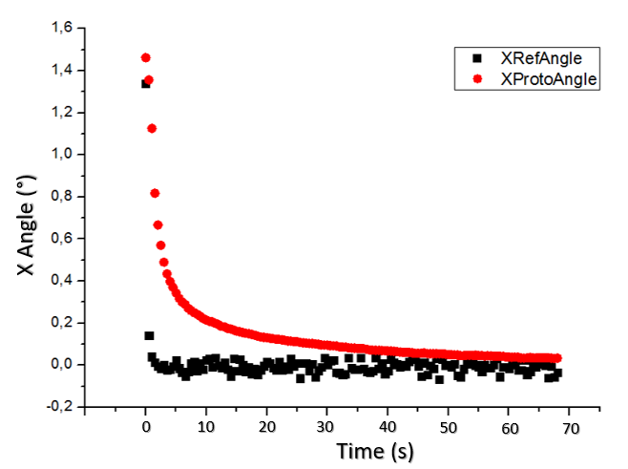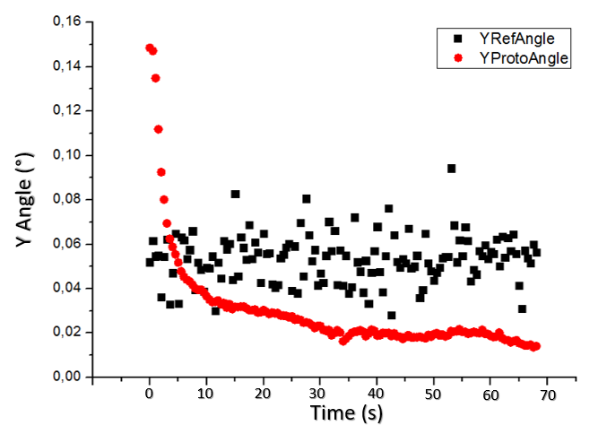
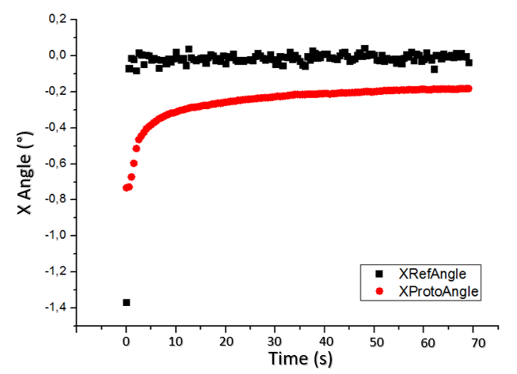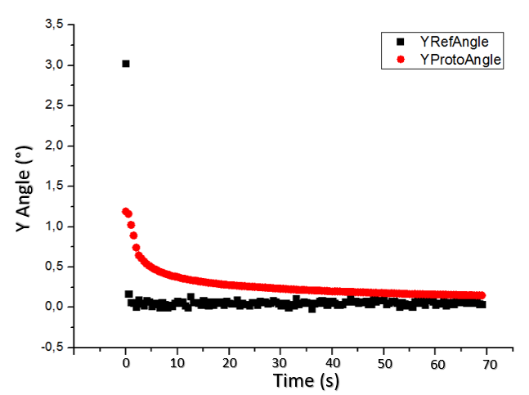

Fig. 10. Top row: Response time and temporal behavior of reference and prototype sensors following a large angle tilt in x-direction, results shown for the x-angle (left) and y-angle (right). Bottom row: Response time and temporal behavior of reference and prototype sensors following a large angle tilt in xy-direction, results shown for the x-angle (left) and y-angle (right). Time interval of 2 acquisitions per second. Reference sensor stabilizes as before around the initial (0°,0°) position in less than 1 second whereas the prototype sensor needs much longer to stabilize and doesn’t get back to its initial position by then.

Repeatability measurements have been performed again by tilting the measurement stage in different random directions and at different angles and measuring the angle to which the inclinometers stabilize after a time interval of 15 seconds (as shown in Figure 11 – top left). An offset has been introduced by resetting the program between two measurements but the mobile mass tends to stabilize around an identical central point. Standard deviation results have been performed in both x and y-axis for the reference and prototype sensor with respectively 0.048° and 0.1° in x-axis and 0.088° and 0.066° in y-axis. The standard deviation results of the prototype inclinometer are higher than those of the reference sensor, which clearly shows that cyclical measurements directly impact the performance of the prototype sensor in terms of precision and consistency.

To even further investigate the effect of time, another set of cyclical measurements have been performed exactly at a one-day interval. Therefore, the prototype sensor has been turned off at a 0°,0° position and turned on 24h later to perform a cyclical measurement experiment. As can be seen in Figure 11 (top right) the linear portion of the graph is very small and the hysteresis very pronounced. The effects of aging seem to increase rapidly over time and the droplet movement loses in dynamics and shows inertia. Additional response time tests (with 2 acquisitions per second) show that the sensor becomes largely unprecise because the mobile mass stabilizes quite rapidly around a point that is very close from its initial position and completely different from the to be measured value.

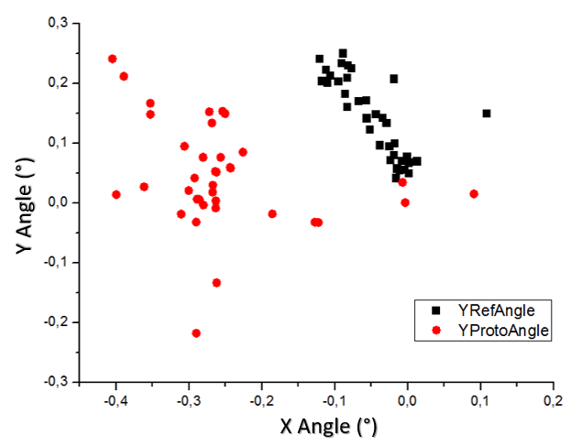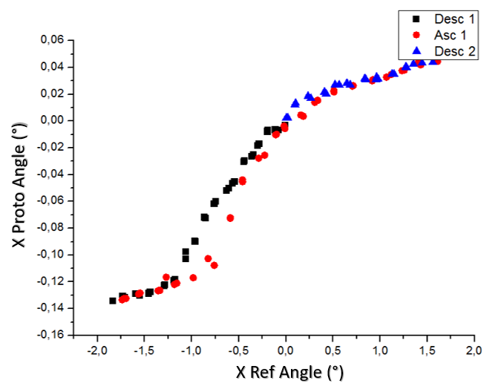

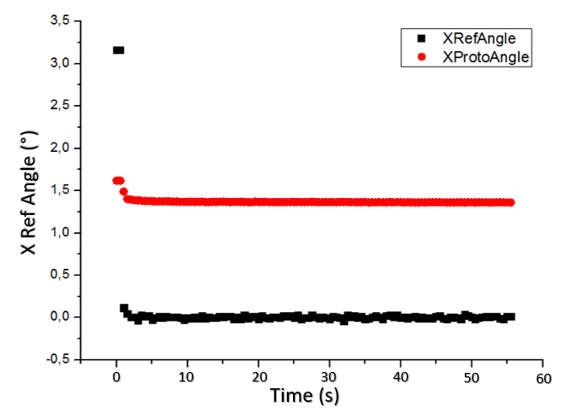

Fig. 11. Top row: Left: Repeatability measurements performed on reference and prototype inclinometers at random tilt and direction after a 2h delay. Standard deviation results show respectively errors of approximatively 0.016° and 0.0079° in x-direction and 0.02° and 0.01° in y-direction. Right: Cyclical measurements performed on the prototype sensor after a 24h delay showing clear signs of linearity loss and hysteresis. Bottom Row: Response time and temporal behavior of reference and prototype sensors following a large angle tilt in x-direction after the same 24h delay showing a clear precision loss of the prototype sensor.

The different experiments described above have demonstrated a clear effect of time and repetition on sensor precision. Cyclical experiments have shown the appearance of significant hysteresis effects in the fluidic case between ascending and descending measurements (data points show a linear progression but are shifted by an offset dependent on the direction of angle change). This hysteresis could be explained by different hypotheses stemming from chemical and physical causes. On the chemical side, a potential reason could involve a chemical interaction between the mercury droplet and the coated black silicon substrate which could lead to the aging or oxidation of the mobile mass, but to our knowledge no evidence has been reported on this issue in literature. On the physical side, repeated sweeps on a substrate presenting a random collection of particles on its surface (experiments have not been performed in a clean room setting) could lead to a particle charged mobile mass (accounting for the “selfcleaning” properties of black silicon), which would then present some degree of surface roughness and induce an altered mobile mass displacement. A more viable hypothesis, that has already been reported in literature³⁶, would be the mechanical impact of the mobile mass displacement on the black silicon substrate leading to an alteration of the nano patterned surface. Nanoscale structures with high aspect ratio are intrinsically extremely fragile with respect to mechanical forces and can be destroyed even by rather low mechanical shear stress (<<1N). The rupture of those high aspect ratio structures has a double effect which can cause significant hysteresis effects: On the one hand broken black silicon structures offer an increased surface for contact line pining and on the other hand they leave hydrophilic “stumps” behind, both of which in turn would induce an increase of the receding contact angle and lead to an alteration of the mobile mass displacement (sticking) and could account for the documented hysteresis.

Recent publications of Ruehe et al.³⁶ were focused on the development of mechanically robust superhydrophobic surfaces by implementing a dual-scale surface combining microcones and nanograss structures. Those surfaces show a greatly improved mechanical durability, especially against shear in comparison with surfaces containing nanostructures only while preserving the superhydrophobic feature and small contact angle hysteresis. The implementation of such a dual scale patterning could prove very interesting for the further development of our inclinometer.

- Conclusion

This paper detailed a high-precision optofluidic bi-axial miniaturized inclinometer based on curved nano-patterned superhydrophobic surface displaying linear behavior over a large part of the measurement range, which can be tuned by adapting the membrane diameter and thickness (by controlling etch time, or using a high-precision SOI substrate). The use of high precision balls combined to bare silicon curved membranes showed sub-0.05° precision levels, the errors being due to mobile mass surface roughness and sphericity errors. Using a fluidic droplet as mobile mass combined to nanopatterned and chemically treated membranes resulted in even better precision, but introduced hysteresis in the system. Improved packaging, better alignment of the optical system with the membrane center and the use of improved membranes led to sub-0.01° state-of-the-art precision levels but hysteresis effects that still need to be addressed to develop an operational sensor combining both high precision and low hysteresis.

7 Acknowledgements

We would like to thank Mr. Eric Laurent, Mr. Gilles Hovhanessian and Mr. Bernard Basile from the Advitam company for providing general technical assistance and civil engineering expertise, and for supplying reference inclinometers for this study. This work was supported by the Region Ile de France through the SIPRIS project.

References

- P.F. Ruesta, F.C. Townsend, Evaluation of laterally loaded pile group at Roosevelt Bridge, J. Geotech. Geoenviron. (1997), 123, 1153-1161

- L. Copland et al., The use of borehole inclinometry in determining basal sliding and internal deformation at Haut Glacier d’Arolla, Switzerland, Ann. of Glaciology (1997), 24, 331-337

- G.A. Hansson et al., Validity and reliability of triaxial accelerometers for inclinometry in posture analysis, Medical and Biological Engineering and Computing (2001), 39, 405-413

4 L. Tang et al., MEMS Inclinometer based on a novel piezoresistor structure, Microelectronics Journal 40 (2009), 78-8

5 L. Shuangfeng, M. Tiehua, H. Wen, Design and fabrication of a new miniaturized capacitive accelerometer, Sensors and Actuators A 147 (2008), 70-74

6 C.H. Lee, S.S. Lee, Study of capacitive tilt sensor with metallic ball, Electronics and Telecommunications Research Institute Journal (2014), 36, 361-366

7 P. Hu, J. Guo, J. Tan, An Annular Planar-Capacitive Tilt Sensor with a 360° Measurement Range, IEEE Transactions on Industrial Electronics (2016), 63, 2469-2476.

8 H.Jung, C.Kim, S.Kong, An optimized MEMS-based electrolytic tilt sensor, Sensors and Actuators A 139 (2007), 23-30

9 W.Bin, M. Hossain, S. Ho Kong, PDMS-based two-axis inclinometer with a 360-degree measuring range, Sensors and Actuators A 239 (2016), 54–60

10 B.Ando, S. Baglio, A. Beninato, A ferrofluid inclinometer with a time domain readout strategy, Procedia Engineering 47 (2012), 586-589

11 J.Bajic et al., A simple, low-cost, high-sensitivity fiber-optic tilt sensor, Sensors and Actuators A 185 (2012), 33-38
12 B. Yao, L. Feng, X. Wang, W. Liu, H. Jiao, Micro-grating tilt sensor with self-calibration and direct intensity modulation, Optik (2015), 126, 144-147.

13 K.-M. Liao, R.Chen, B.Chou, A novel thermal-bubble-based micromachined accelerometer, Sensors and Actuators A 130-131 (2006), 282-289

14 A. Garraud, A. Giani, P. Combette, B. Charlot, M. Richard, A dual axis CMOS micromachined convective thermal accelerometer, Sensors and Actuators A 170 (2011), 44-50

15 T.Constandinou, J.Georgiou, Micro-Optoelectromechanical Tilt Sensor, Journal of Sensors (2008), 782764

- X.Tao, L.Haibao, L.Wusheng, A robust photoelectric angular position sensor especially for a steerable underground boring tool, Sensors and Actuators A 120 (2005), 311-316

- H.Kato, M. Kojima, M. Gattoh, Y. Okumura, S. Morinaga, Photoelectric inclination sensor and its application to the measurement of the shapes of 3D-objects, IEEE Transactions on Instrumentation and Measurement 40 (1991), 1021-1026

- D.Welch, J.Georgiou, J.Christen, Fully differential current-mode MEMS dual-axis optical inclination sensor, Sensors and Actuators A 192 (2013), 133-139

- ADIS16209 High accuracy, dual axis digital inclinometer and accelerometer, Analog Devices datasheet (2012)

- T. Bourouina, T. Masuzawa, H. Fujita, The MEMSnas process: microloading effect for micromachining 3-d structures of nearly all shapes, Microelectromech. S. (2004), 13, 190

- T. Chou, K. Najafi, Fabrication of out-of-plane curved surfaces in Si by utilizing RIE lag (2002), 15th IEEE International Conference on MEMS, 145

- K.N. Nguyen, P. Basset, F. Marty, Y. Leprince-Wang, T. Bourouina, On the optical and morphological properties of microstructured Black Silicon obtained by cryogenic-enhanced plasma reactive ion etching, J. Appl. Phys (2013), 113, 194903

- R.T.R. Kumar, K.B. Mogensen, P. Bøggild, Simple Approach to Superamphiphobic Overhanging Silicon Nanostructures, J. Phys. Chem. C (2010), 114, 2936-2940

- N. Gaber, M. Malak, X. Yuan, K.N. Nguyen, P. Basset, E. Richalot D. Angelescu, T. Bourouina, On the free-space Gaussian beam coupling to droplet optical resonators, Lab Chip (2013), 13, 826-833

- D. Abi-Saab, P. Basset, M.J. Pierotti, M.L. Trawick, D.E. Angelescu, 3D reconstruction of silicon micro/nanostructures, based of FIB-SEM tomography, Phys. Rev. Lett. (2014), 113, 265502

- H. Hencky, On the Stress State in Circular Plates With Vanishing Bending Stiffness, Zeitschrift für Mathematik und Physik (1915), 63, 311-317

- R. Kao, N. Perrone, Large deflections of axisymmetric circular membranes, J. Solids Structures (1971), 7, 1601-1612

- W.C. Young, R.G. Budynas, A.M. Sadegh, Roark’s Formulas for Stress and Strain (8th ed.), McGraw-Hill, 2011

- W.B. Fichter, Some solutions for the large deflections of uniformly loaded circular membranes, NASA Technical Paper (1997), No. 3658

- J.T. Katsikadelis, M.S. Nerantzaki, G.C. Tsiatas, The analog equation method for large deflection analysis of membranes. A boundary-only solution, Computational Mechanics (2001), 27, 513-523

- A. Salette, R. Lefevre, C. Agraffeil, J. Guillen, C. Déhan, P. Morfouli, L. Montès, Thermal sensors cointegrated within a MEMS thermally actuated ultrathin membrane, J. Micromech. Microeng. (2012), 22, 065029

- A.G.Striz, S.K..Jang, C.W.Bert, Nonlinear Bending Analysis of Thin Circular Plates by Differential Quadrature, Thin Walled Structures (1988), 6, 51-62

- S. Timoshenko, S. Woinowsky-Krieger, Theory of plates and shells (2nd ed.), McGraw-Hill, 1959

- D. Quéré, Non-sticking drops, Rep. Prog. Phys. (2005), 68, 2495-2532

- L.Gao, T.McCarthy, The “Lotus Effect” Explained: Two Reasons Why Two Length Scales of Topography Are Important, Langmuir (2006), 22, 2966-2967

- V. Kondrashov, J. Ruehe, Microcones and Nanograss: Toward Mechanically Robust Superhydrophobic Surfaces, Langmuir (2014), 30, 4342−4350

- J. Zimmermann,F.A. Reifler, G. Fortunato, L. Gerhardt, S. Seeger, A simple, one-step approach to durable and robust superhydrophobic textiles, Adv. Funct. Mater. (2008), 18, 3662−3669

- X. Yue, Weidong Liu, Y. Wang, Effects of black silicon surface structures on wetting behaviors, single water droplet icing and frosting under natural convection conditions, Surface & Coatings Technology (2016), 307 278–286

- Y.-L. Zhang, J.N. Wang, Y. He, B.B. Xu, S. Wei,F.S. Xiao, Solvothermal synthesis of nanoporous polymer chalk for painting superhydrophobic surfaces, Langmuir (2011), 27, 12585−12590.

- J. Ou, B. Perot, J.P. Rothstein, Laminar drag reduction in microchannels using ultrahydrophobic surfaces. Phys. Fluids (2004), 16, 4635−4643.

- P.A. Tsai, Slippery interfaces for drag reduction. J. Fluid Mech. (2013), 736, 1−4.

- J.S. Li, H.Y. Yu, S.M. Wong, et al, Si nanopillar array optimization on Si thin films for solar energy harvesting. Appl Phys Lett (2009), 95, 033102–033104

- A.B.D. Cassie, S. Baxter, Trans. Faraday Soc. (1944), 40, 546.

- K. Koch, B. Bhushan, Y.C. Jung, W. Barthlott, Fabrication of artificial Lotus leaves and significance of hierarchical structure for superhydrophobicity and low adhesion, Soft Matter (2009), 5, 1386-1393

45 C. Dorrer, J. Ruehe,

Advancing and Receding Motion of Droplets on Ultrahydrophobic Post Surfaces, Langmuir (2006), 22, 7652-7657

46 C. Dorrer, J. Ruehe, Micro to nano: Surface size scale and superhydrophobicity, Beilstein J. Nanotechnol. (2011), 2, 327–332

47 C.Dorrer, J. Ruehe, Wetting of Silicon Nanograss: From Superhydrophilic to Superhydrophobic Surfaces, Advanced Materials (2008), 20, 159 - 163

